**ASSIGNMENT-1**

**Name :-NITESH KUMAR**

**Class :- BCA 1ST YEAR**

**Roll no :- 15**

**Subject :- WEB TECHNOLOGY II**

**Section :- H**

**University no: 2342010426**

Submitted By- NITESH KUMAR Submitted to- MR. Jayati Krishna

Goswami

Q1.Create a program for a shopping cart. If the total price is over Rs. 5000, apply a 10% discount; otherwise, log the original price.

CODE 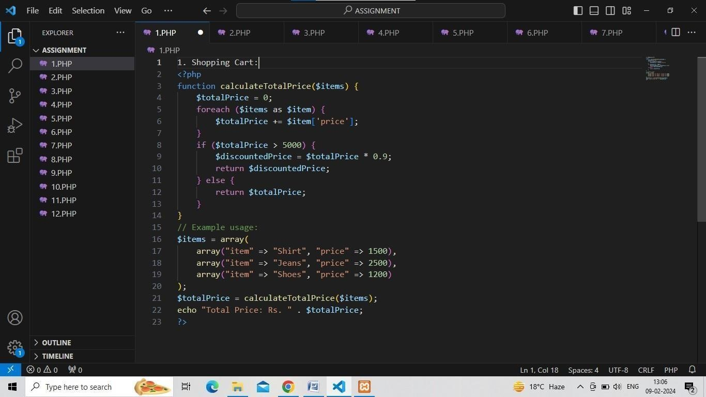

OUTPUT

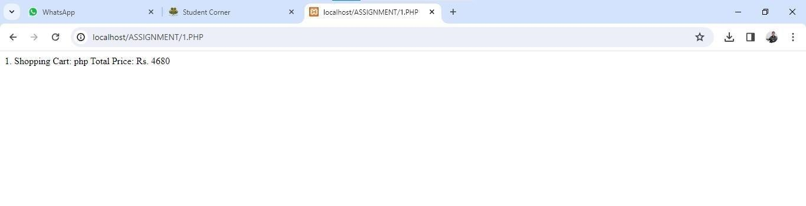

Q2.Simulate a traffic light system using if-else statements. Log the appropriate message for each colour of the traffic light

(e.g. "Green- Go," "Yellow - Slow down,'" "Red - Stop")

CODE:-

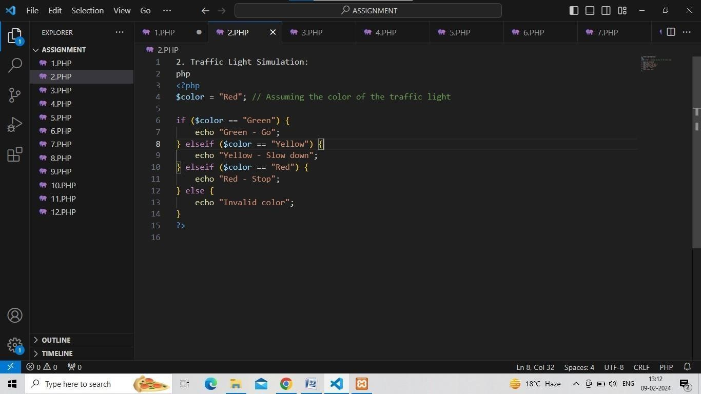

OUTPUT:-

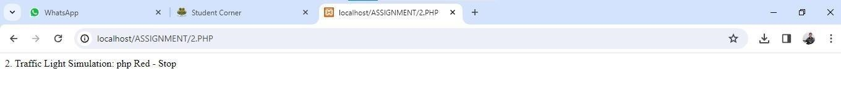

Q3.Create a PHP program for a fitness app. The program will take the number of steps walked in a day as input and determine the fitness level based on the following rules:

If the number of steps is less than 5000, the fitness level is 'Beginner'.

If the number of steps is between 5000 and 10000 (inclusive), the fitness level is

'Intermediate'

If the number of steps is greater than 10000, the fitness level is

'Advanced".

Provide a PHP code snippet for this program, including the conditional statements to determine the fitness level based on the input number of steps.

CODE:-

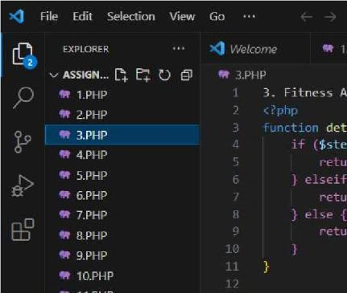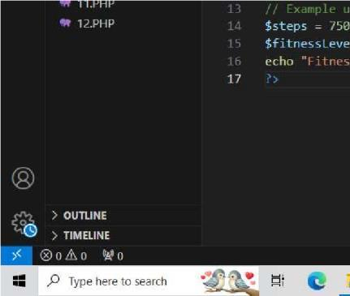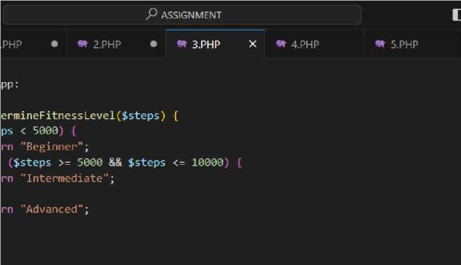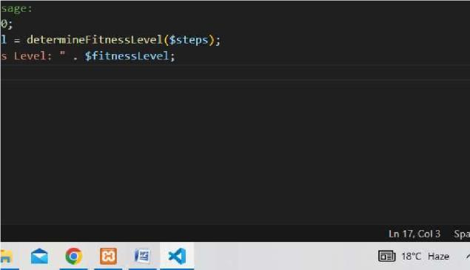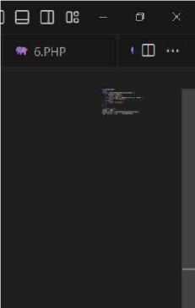

OUTPUT:-

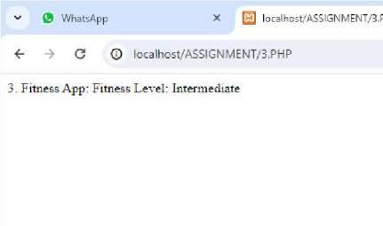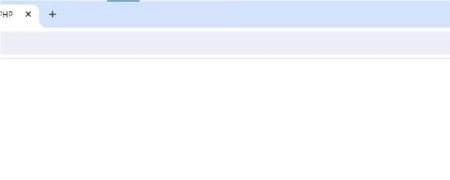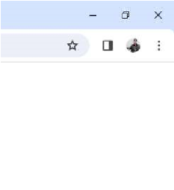

4. Develop a PHP program for a grading system. The program will take a student's score as input and determine the grade based on the following rules:

If the score is less than 60, the grade is 'F

If the score is between 60 and 70 (inclusive), the grade is

'D'.

If the score is between 71 and 80 (inclusive), the grade is 'C".

If the score is between 81 and 90 (inclusive), the grade is

'B'.

If the score is greater than 90, the grade is 'A'.

Provide a PHP code snippet for this program, including the conditional statements to determine the grade based on the input score

CODE:-

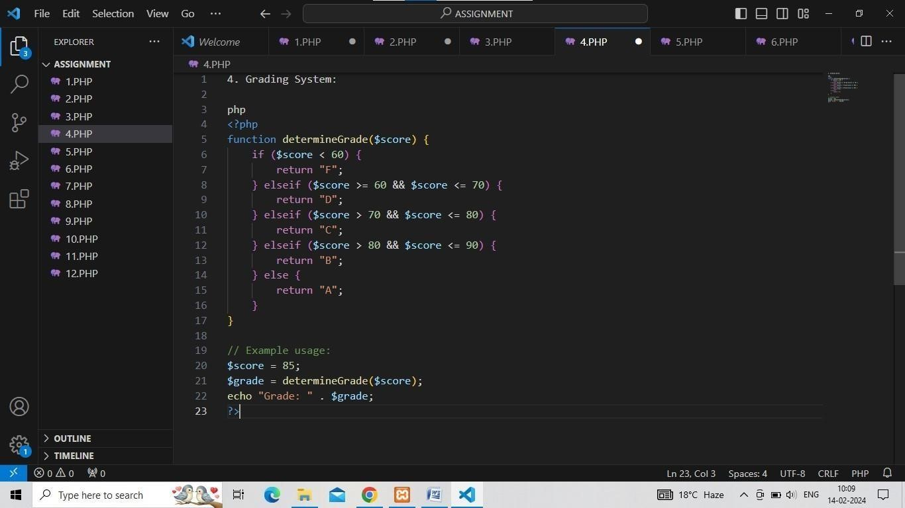

OUTPUT:-

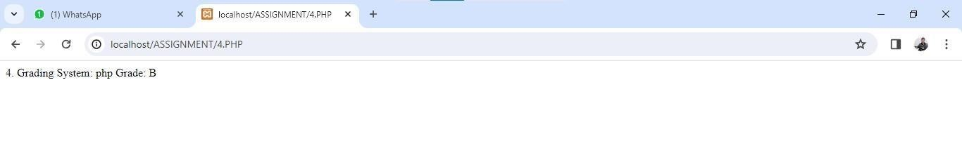

Q5. Scenario: Suppose you are developing a website for an online store. The store offers a discount on orders over Rs.

1000. Write

a piece of PHP code using conditional control structures to

check if the total order amount qualifies for the discount and display an appropriate message to the user.

CODE:-

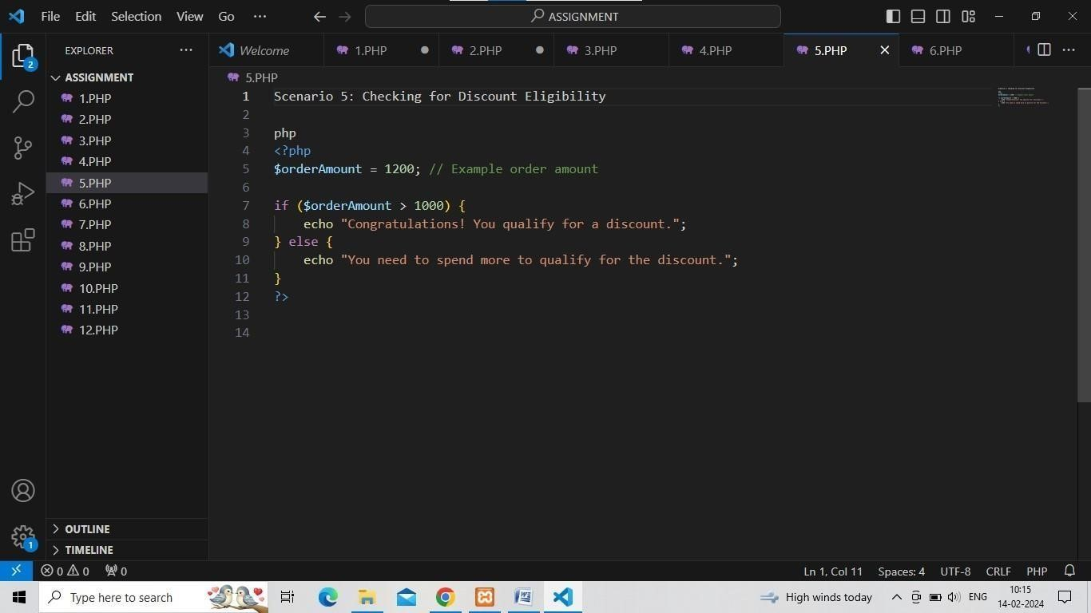

OUTPUT:-

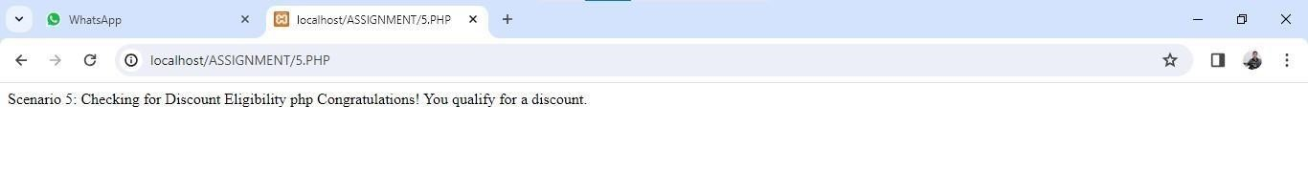

Q6 . Scenario: You are building a login system for a web application.

After users submit their username and password, you need to

verify if the credentials are correct before granting access. Write a PHP script that checks if the provided username and password match the stored credentials. If they match, echo "Login successful"; otherwise, echo "Invalid

credentials" CODE:-

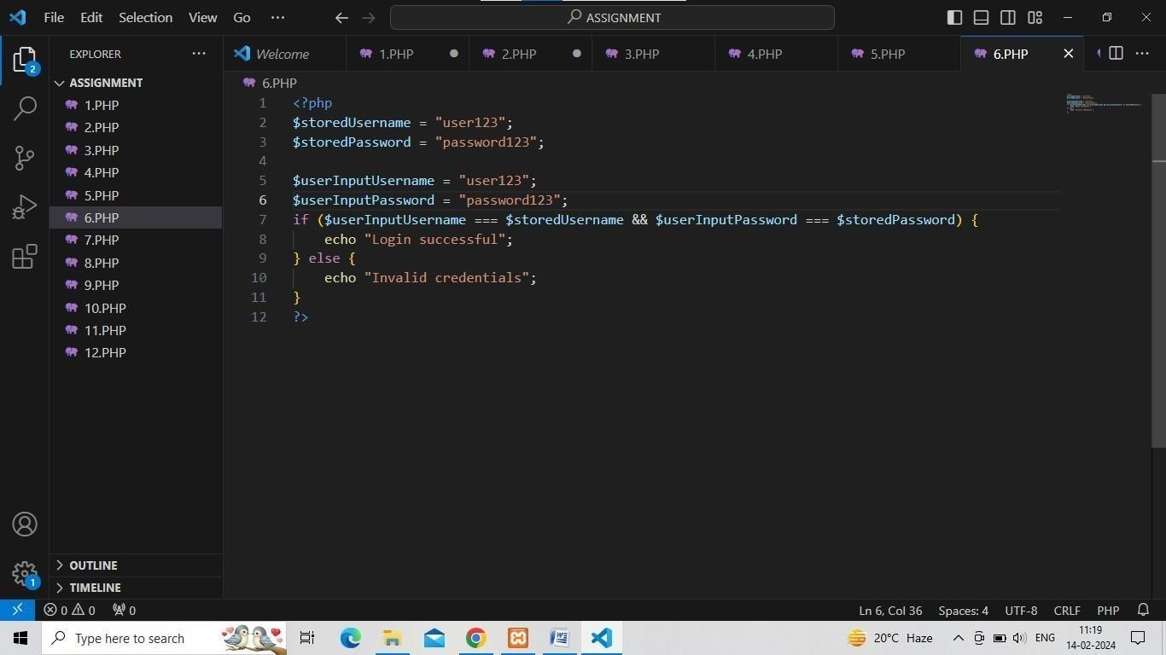

OUTPUT:-

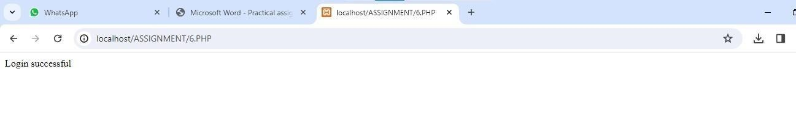

Q7. Scenario: Imagine you are developing a weather application.

Depending on the current temperature, the application provides

Different recommendations. Write a PHP script that takes he

current temperature as input and outputs a recommendation. For example, if the temperature is above 25°C, echo "It's a sunny day!"; otherwise, echo "Consider taking an umbrella" CODE:-

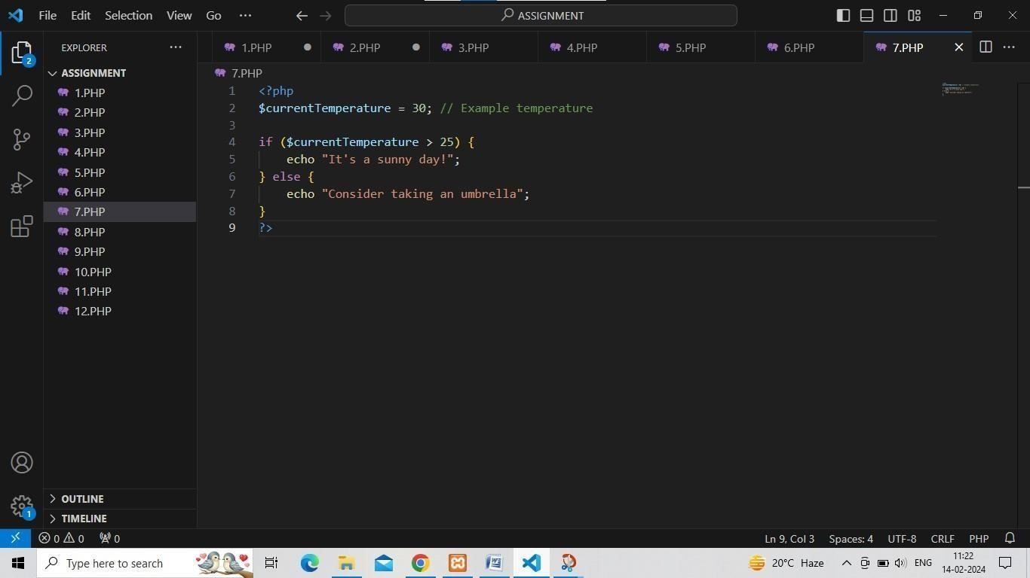

OUTPUT:-

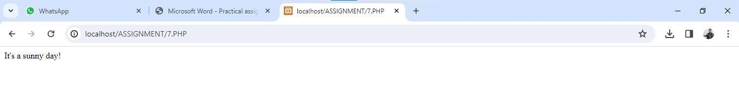

Q8. Scenario: You are creating a grading system for a school website.

Based on the score obtained by a student in an exam, you need to assign a grade. Write a PHP script that takes the score as input and assigns a grade according to the following criteria:

Score >= 90: Grade A

Score >= 80: Grade B Score >= 70: Grade C

Score >= 60: Grade D

Score < 60: Grade &F

CODE:-

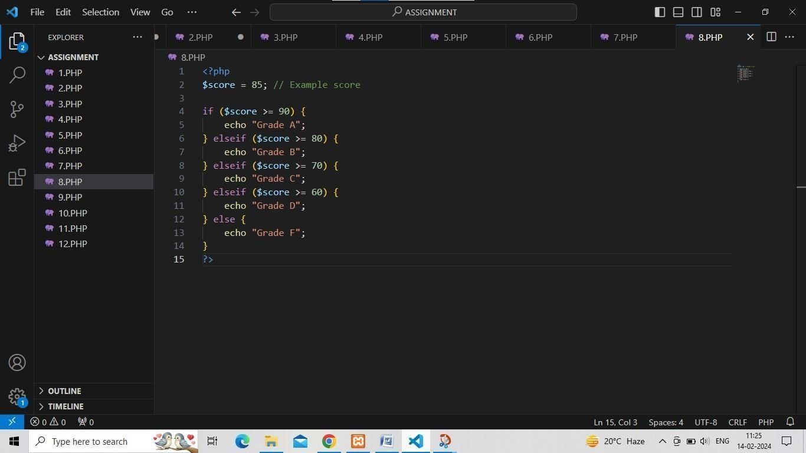

OUTPUT:-

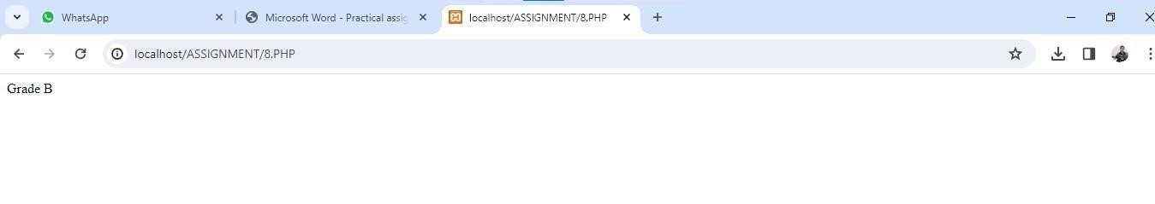

Q9. Scenario: Suppose you are developing a user profile

Page for d

social media platform. You want to display different messages to

users based on their account type (e.g., basic or premium). Write

a PHP script that checks the user's account type and displays a

personalized message accordingly. For example, if the user has a

premium account, echo ""Welcome Premium User!"; otherwise

echo "Welcome Basic User!"

CODE:-

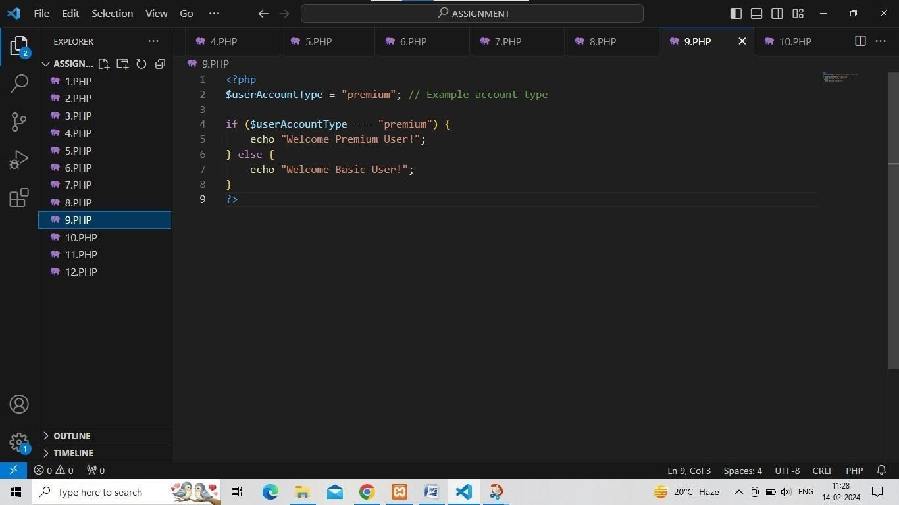

OUTPUT:-

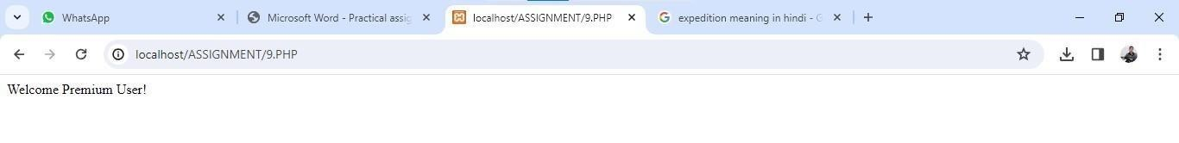

Q10. Scenario: You are developing a blog platform where users can

publish articles. However, you want to implement a feature that

Limits the length of article titles to 50 characters. Write a PHP

script that checks the length of the article title and truncates it to

50 characters if it exceeds the limit.

CODE:-

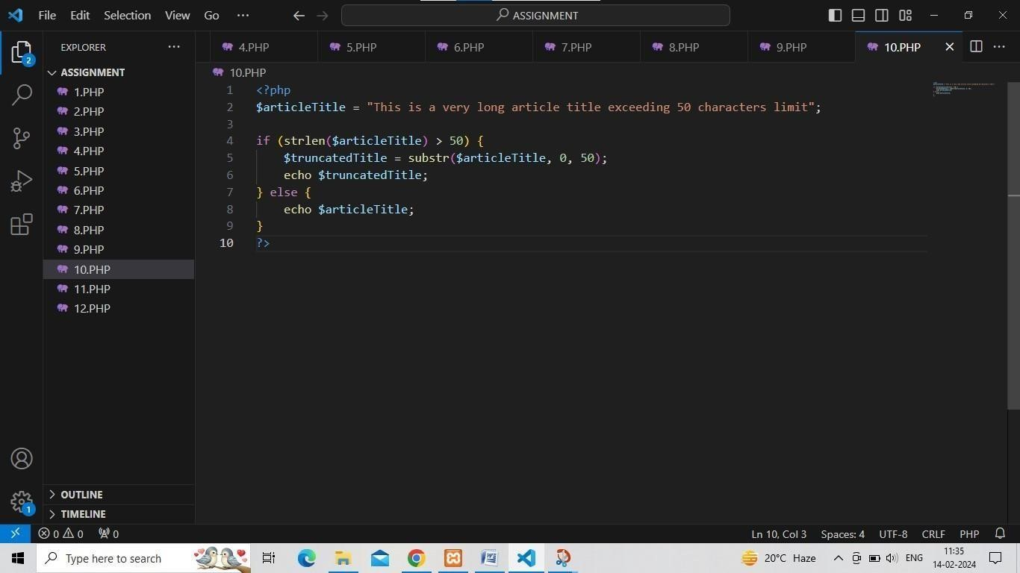

OUTPUT:-

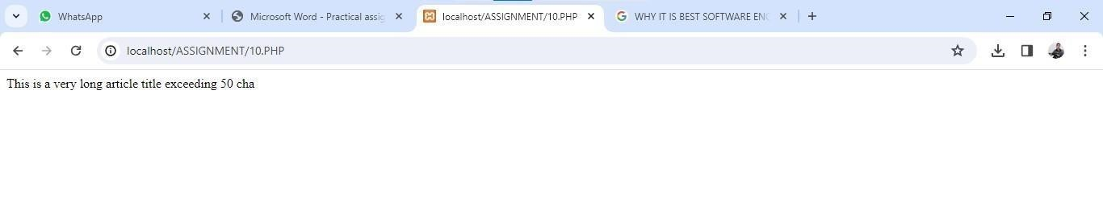

Q11.Scenario: Suppose you are developing a quiz application where users can attempt multiple-choice questions. You want to

implement a feature that calculates the user's score based on the

number of correct answers. Write a PHP script that calculates the user's score and displays it at the end of the quiz.

CODE:-

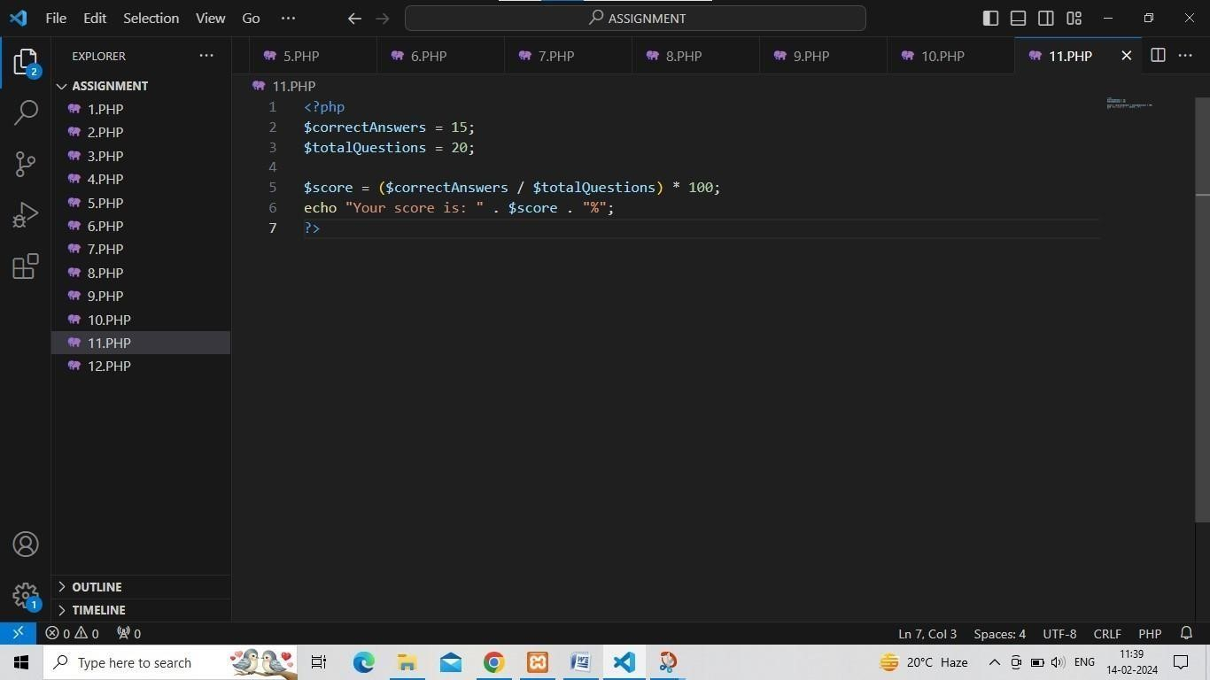

OUTPUT:-

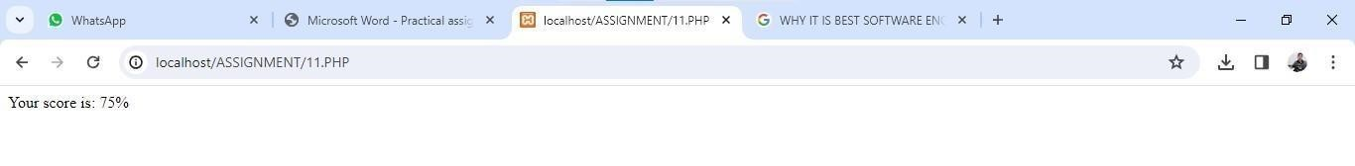

Q12. Scenario: You are building a subscription-based service where users can choose between different subscription plans. However,

you want to offer a trial period for new users. Write a PHP script

that checks if the user is a new user and offers them a trial period if they haven't subscribed before.

Edit

Tools

Selection

CODE:-

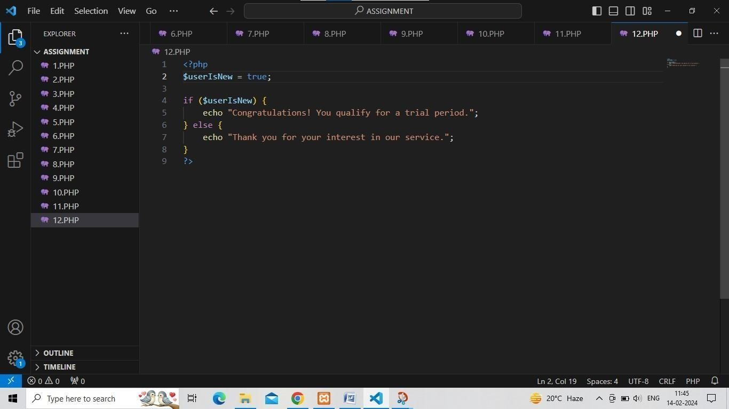

OUTPUT:-

